RICHARD MILLE FIFE REGATTA
4
06-12 June 2026
The Firth of Clyde and Loch Fyne, Scotland, UK

AMENDMENT No4 TO THE SAILING INSTRUCTIONS

SI E2.1
Delete SI E2.1
SI E2.2 Delete “Class 3 only” and replace with “Class 1”, therefore on 12 June 2026 Class 1 will sail the course described in SI E2.2.
Class 3 will sail the course shown below:
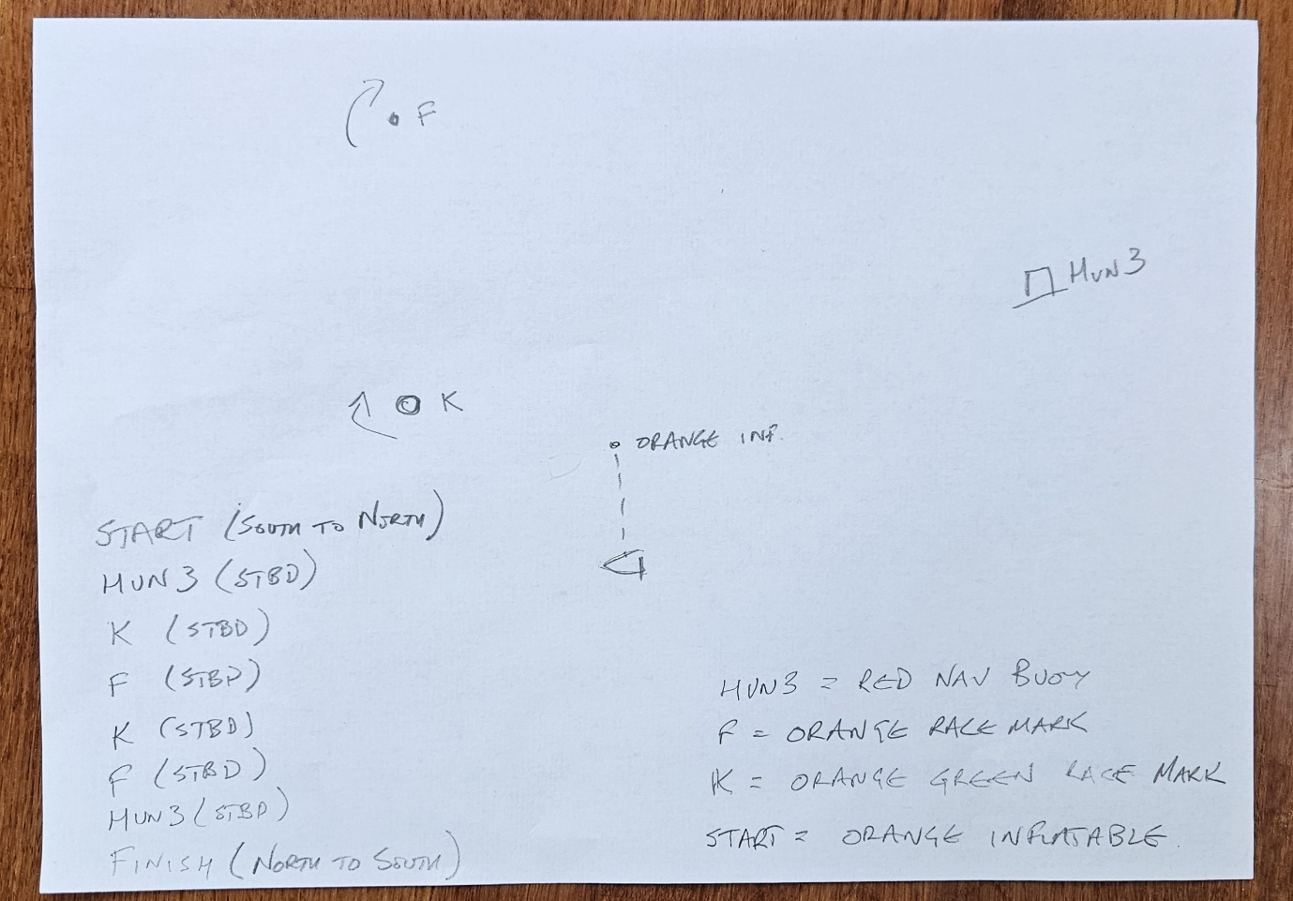

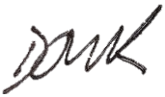
D Kent, Race Officer, 0917, 12 JUN 2026

